Genuine Device Detection Subsystem 1.0.0

User Guide (OEM)

GDDS-User-Guide-OEM-1.0.0

November 23, 2020

Revision history

|  |  |  |
| --- | --- | --- |
| Revision | Date | Description |
| A | November 2020 | First Release |

# Contents

1. Introduction 4

1.1. Purpose 4

1.2. Supported Desktop Browsers 4

1.3. Supported Mobile Browsers 5

1.4. Definitions, Acronyms, and Abbreviations 5

2. System Description 6

3. System Navigation 7

3.1. Login Screen 7

3.2. Portal Sections 8

3.3. Home Page 9

3.4. Enter Missing Information 10

3.5. Bulk Upload 12

**Figures**

Figure 1 - Login Screen 7

Figure 2 - Portal Sections 8

Figure 3 - Home Page 9

Figure 4 - Enter Missing Information (i) 10

Figure 5 - Enter Missing Information (ii) 11

Figure 6 - Download all requests document 12

Figure 7 - Bulk Upload (i) 12

Figure 8 - Bulk Upload (ii) 13

**Tables**

Table 1 - Supported Desktop Browsers 4

Table 2 - Supported Mobile Browsers 5

Table 3 - Definition, Acronyms, and Abbreviations 5

Table 4 - System Description 6

# 

# **Introduction**

Genuine Device Detection Subsystem (GDDS) is the subsystem of Device Identification, Registration & Blocking System (DIRBS). It provides a platform for OEM(s) to respond with correct/missing device information i.e. Serial Number, Color, Brand, and Model Name, MAC address and RAT to verify the authenticity of the device(s).

The Device Identification, Registration & Blocking System (DIRBS) is a country-wide system deployed in cooperation between the country regulator, operators in that country, and a technology partner that supports deployment. The system checks, identifies, and discourages non-compliant devices by verifying the installed base of devices currently active in a market and continuing to monitor as new devices are activated.

DIRBS can verify that:

* Devices have properly allocated identifiers and type approval
* Devices are not duplicated or stolen
* Device importation takes place through legal channels

# **Purpose**

This document is intended to give assistance to the user to use the Genuine Device Detection Subsystem (GDDS).

# **Supported Desktop Browsers**

Table 1 - Supported Desktop Browsers

|  |  |
| --- | --- |
| **Name** | **Version** |
| Internet Explorer | 11.0 |
| Firefox | 82.0.3 |
| Chrome | 86.0 |
| Safari | 13.1.2 |
| Edge | 86.0 |

# **Supported Mobile Browsers**

Table 2 - Supported Mobile Browsers

|  |  |
| --- | --- |
| **Name** | **Version** |
| Chrome | 86.0.4 |
| UC Browser | 13.3.3 |
| Opera (Android) | 60.3 |
| Opera Touch (iOS) | 2.5.1 |
| Safari | 13.1.2 |
| Samsung Internet | 13.0.1 |
| Android | 10 |

# **Definitions, Acronyms, and Abbreviations**

Table 3 - Definition, Acronyms, and Abbreviations

|  |  |
| --- | --- |
| ****Term**** | ****Definition**** |
| **DIRBS** | **Device Identification Registration and Blocking System** |
| IAM | Identity Access Management System |
| GDDS | Genuine Device Detection Subsystem |
| MSISDN | Mobile Subscriber Integrated Services Directory Number |
| IMEI | International Mobile Equipment Identity |
| OEM | Original Equipment Manufacturer |

# 

# **System Description**

Table 4 - System Description

|  |  |
| --- | --- |
| Feature/Sections | ****Explanation**** |
| Registration | * **Allows user to register his/her account, associate and de-associate device(s).** |
| Login Screen | * To access the system, authorized user first needs to enter his/her credentials on login page, this login page authenticates user from IAM and redirects user to GDDS. |
| Portal Sections | The portal is divided into the following sections.   * **Header**   **Header section displays name of the system and it contains following features.**   * **User Profile Drop-down**   **Displays the user name with logout functionality.**   * **Navigation Panel**   Navigation Panel contains main navigation menu through which user can navigate the whole system.   * **Main Content Area**   Main Content Area contains all the content to be displayed and actions to be performed for respective feature.   * **Breadcrumbs**   Breadcrumbs allow user to keep track of their location within the system.   * **Footer**   Footer contains the software version and copyrights statement. |
| OEM Home Page | * Home Page displays IMEIs in a tabular form for which OEM has to provide missing information i.e. Serial number, Color, Brand, Model Name, MAC address and RAT. |
| Download All Requests | Facilitates user to download all IMEI requests in a file i.e. CSV file format. |
| Bulk Upload | Allows user to upload all IMEI requests with missing information in a file i.e. CSV file format. |

# **System Navigation**

# **Login Screen**

1. **Enter your credentials i.e. Username and Password.**
2. **Click on the “Log in” button.**

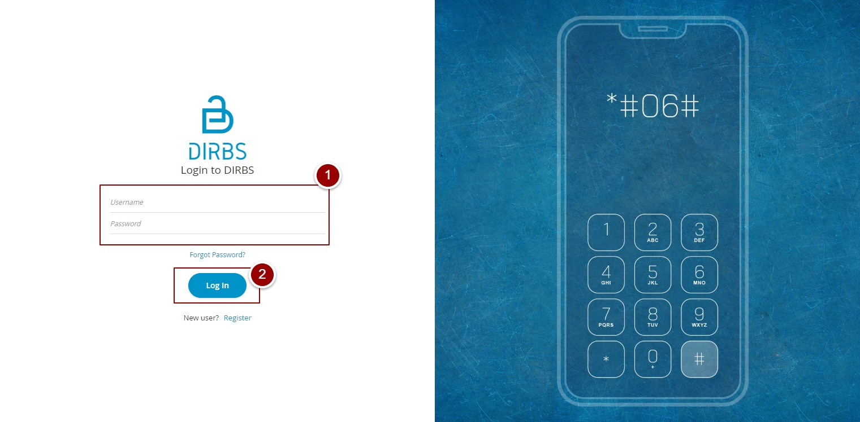

Figure 1 – Login Screen

# **Portal Sections**

The portal screen is divided into following sections.

1. **Header** section displays name of the system, a dropdown menu for language selection, notification alert icon and name of logged in user with logout functionality.
2. **Main Navigation Panel** helps user to navigate the system.
3. **Breadcrumbs** is a navigational aid in UI.
4. **Main Content Area** contains all relevant information related to the respective feature/option.
5. **Footer** contains version and copyrights of the system.

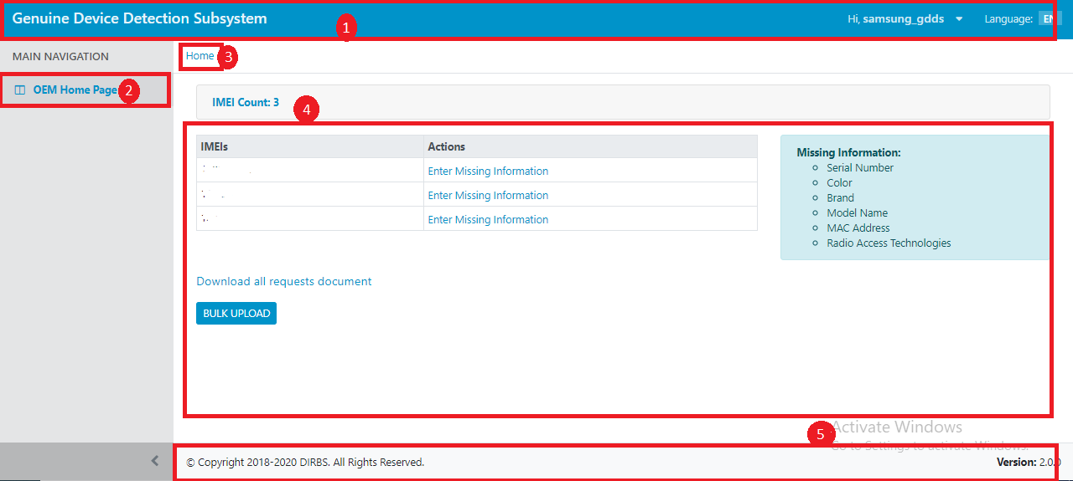

Figure 2 - Portal Sections

# 

# **Home Page**

By clicking on “login” button, user will be redirected to OEM Home Page screen that displays the IMEIs which are marked as duplicate. OEM has to share missing information against particular IMEI(s).

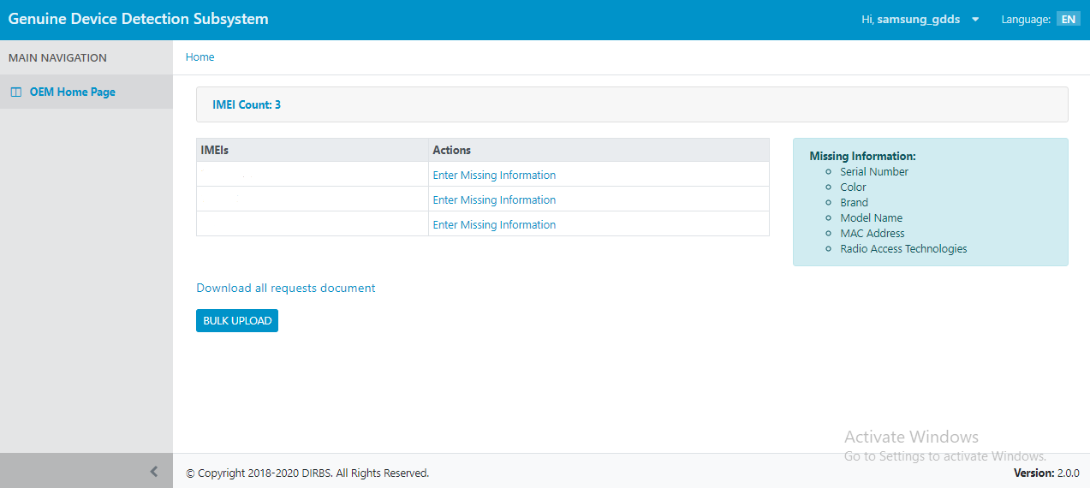

Figure 3 - Home Page

# **Enter Missing Information**

1. To enter missing information, click on “Enter Missing Information” link.

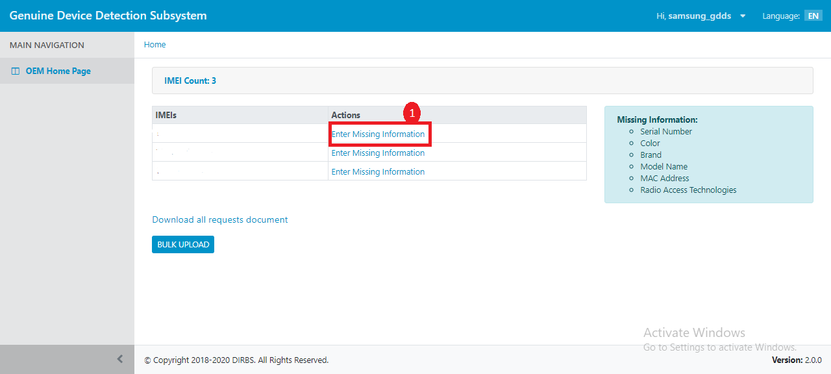

Figure 4 - Enter Missing Information (i)

A popup will appear where user has to mention required information.

1. Enter serial number of the device,
2. Enter color of the device.
3. Enter brand name of the device.
4. Enter model name of the device.
5. Enter Mac address of the device.
6. Enter RAT of the device.
7. Click on “ADD” button.

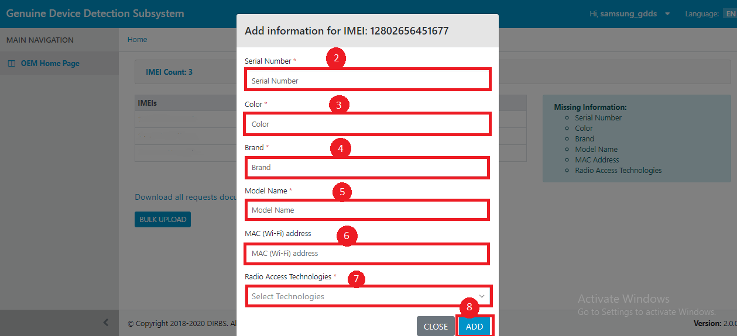

Figure 5 - Enter Missing Information (ii)

# **Bulk Upload**

To upload missing information against all IMEIs in bulk, OEM has to first download all the requests.

1. To download all requests, click on “Download all requests document” link. A file will be downloaded in .csv format.

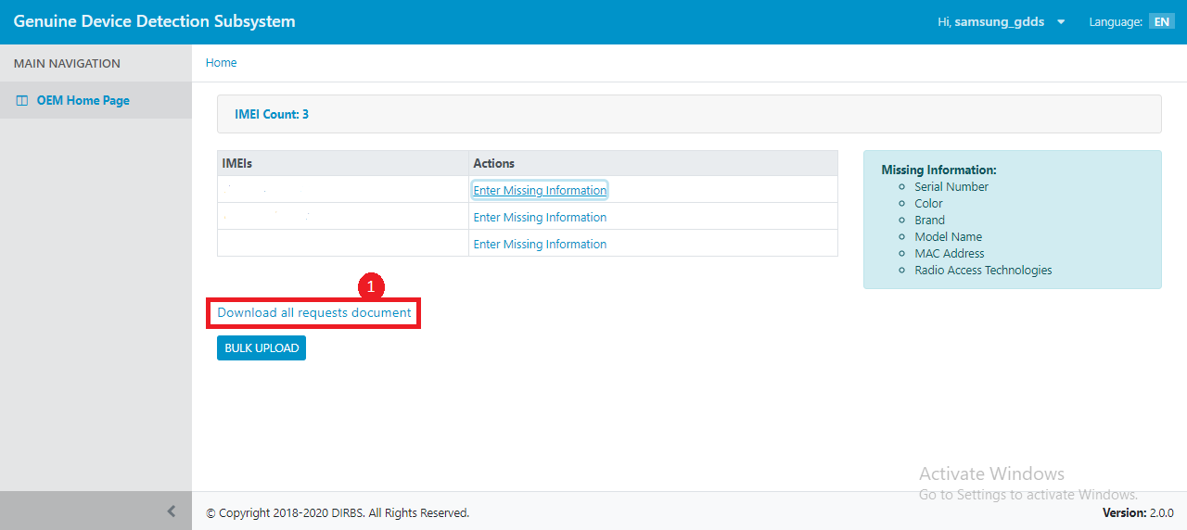Figure 6 - Download all requests document

1. To upload all requests in bulk, click on “Bulk Upload” button. 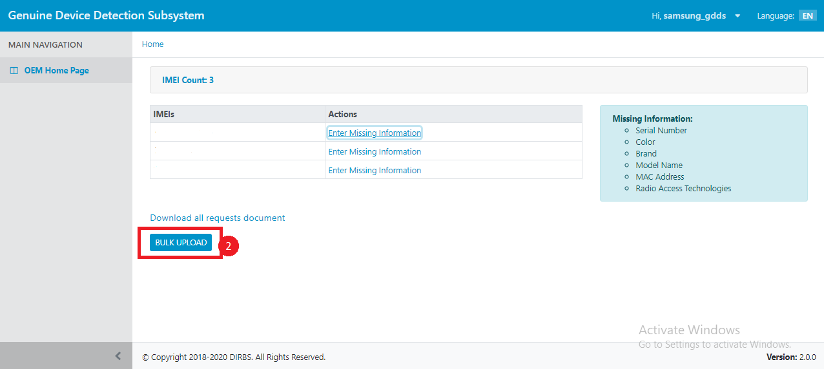

Figure 7 - Bulk Upload (i)

A popup will appear where user has to select and submit file.

1. Select the file to upload.
2. Click on “Submit” button.

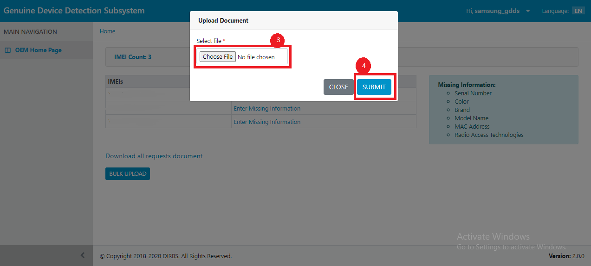

Figure 8 - Bulk Upload (ii)